Fall 2018

**Final Project Report**

**Group 4**

Rushil Anand

Jack Dunn

Arpit Sharma

Vedika Shenoy

Sayali Suryawanshi

Latika Wadhwa

IST 687 – M003

Introduction to Data Science

Instructors:

Jeffery Saltz, Eric Anderson, Ivan Shamshurin

Dec 06, 2018

## CONTENTS

1. INTRODUCTION 2

2. PREPARING THE DATA 3

2.1 OUR CHOICE IN VARIABLES 3

2.2 CLEANING DATA 4

2.3 CONVERTING DATA INTO BINS 4

2.4 CREATING THE TEST AND TRAIN DATA SETS 5

3. EXPLORATION OF VARIABLES 7

3.1 SCHEDULED DEPARTURE HOUR AND DEPARTURE DELAY 7

3.2 TYPE OF CLASS AND DELAY 7

3.3 FLIGHTs CANCELLED AND ARRIVAL DELAY IN MINUTES 8

3.4 GENDER AND PRICE SENSTIVITY 9

3.5 EATING AND SHOPPING AT AIRPORT 10

4. MODELS 11

4.1 LINEAR REGRESSION MODEL 11

4.2 ASSOCIATION RULES 13

4.3 DECISION TREE 14

4.4 SUPPORT VECTOR MACHINE 17

5. VALIDATION OF MODELS 19

6. VISUALIZATION OF VARIABLES 20

7. CONCLUSION 26

8. REFERENCES 27

9. APPENDIX 28

9.1 R CODE 28

9.2 TRELLO BOARD 28

9.2 DIVISION OF TASKS 29

## INTRODUCTION

We were given a customer survey dataset of customers flying within the United States. We were tasked with finding the factors that would affect the overall satisfaction of the customers.

We used Trello Board to keep track of the tasks that each team member undertook during the course of the project.

We primary used R to analyze the data and run predictive machine learning algorithms. However, we also used Excel in a limited number of cases to transform the data.

Some of the specific business question we wanted to answer -

* + - * Which of the factors surveyed are likely to affect the overall customer satisfaction?
      * Do obvious factors like the Airline ticket prices, flight arrival delay or cancellation really affect the overall customer satisfaction?
      * Are there any generalized trends across all the airlines?
      * What type of travelers are most satisfied with the airlines?
      * What type of travelers are least satisfied with the airlines?
      * What class of travelers are the least satisfied?
      * Between men and women, who is more satisfied with the airlines?

## PREPARING THE DATA

In this section, we will explore what we did to clean up the data and transform it into a form that we need for our models.

## 2.1 OUR CHOICE IN VARIABLES

We decided to focus on the below list of variables -

**Airline Status** – each customer has a different type of airline status or package: platinum, gold, silver, and blue.

**Age** – the specific customer’s age. The age ranges from 15 to 85 years old.

**Gender** – male or female.

**Price Sensitivity** – the grade to which the price affects to customers purchasing. The price sensitivity has a range from 0 to 5.

**Type of Travel** – provides three traveling purpose for each consumer: business travel for business purpose, mileage tickets which are based on loyalty card, and personal travel who like to see the family or in vacation.

**Shopping Amount at Airport** – showing the costumer’s result of how many products have been purchased. The range of shopping amount is from 0 to 875.

**Eating and Drinking at Airport** – the quantity of eating and drinking per each consumer at the airport. The measure of how often eating and drinking was done, this lies between 0 and 895.

**Class** – consisted of three different kinds of service level such as, business, and economy plus, economy. Moreover, customers have option to choose their seat.

**Scheduled Departure Hour** – the specific time at which passengers are scheduled to depart. In this data scheduled departure hour is starting at 1 am until 23 pm.

**Departure Delay in Minutes** – minutes of departure delay for each passenger, when compared to schedule. In this data the range is starting from 0 until 1128 minutes.

**Arrival Delay in Minutes** – shows by how many minutes the arrival delayed of each passenger. Range of delayed minutes starts from 0 until 1115 minutes.

**Flight Cancelled** – occurs when the airline dose not operate the flight at all, and that is for a certain reason.

**Flight time in minutes** – indicate the period time to the destination.

**Arrival Delay greater 5 Minutes** – It means the delay of arrival airline time, which is more than 5 minutes per passenger in the data.

These were the variables that we found interesting. They all had significant p-values in a linear model using all the attributes. The information was not captured in another variable. There was no information about the airline or location, both of which we decided to not focus on in this project.

## 2.2 CLEANING DATA

We had to start by converting Satisfaction into a data type of numeric. Once that was done, we could count the number of NAs which turned out to 3, so we just deleted those rows since it were so few.

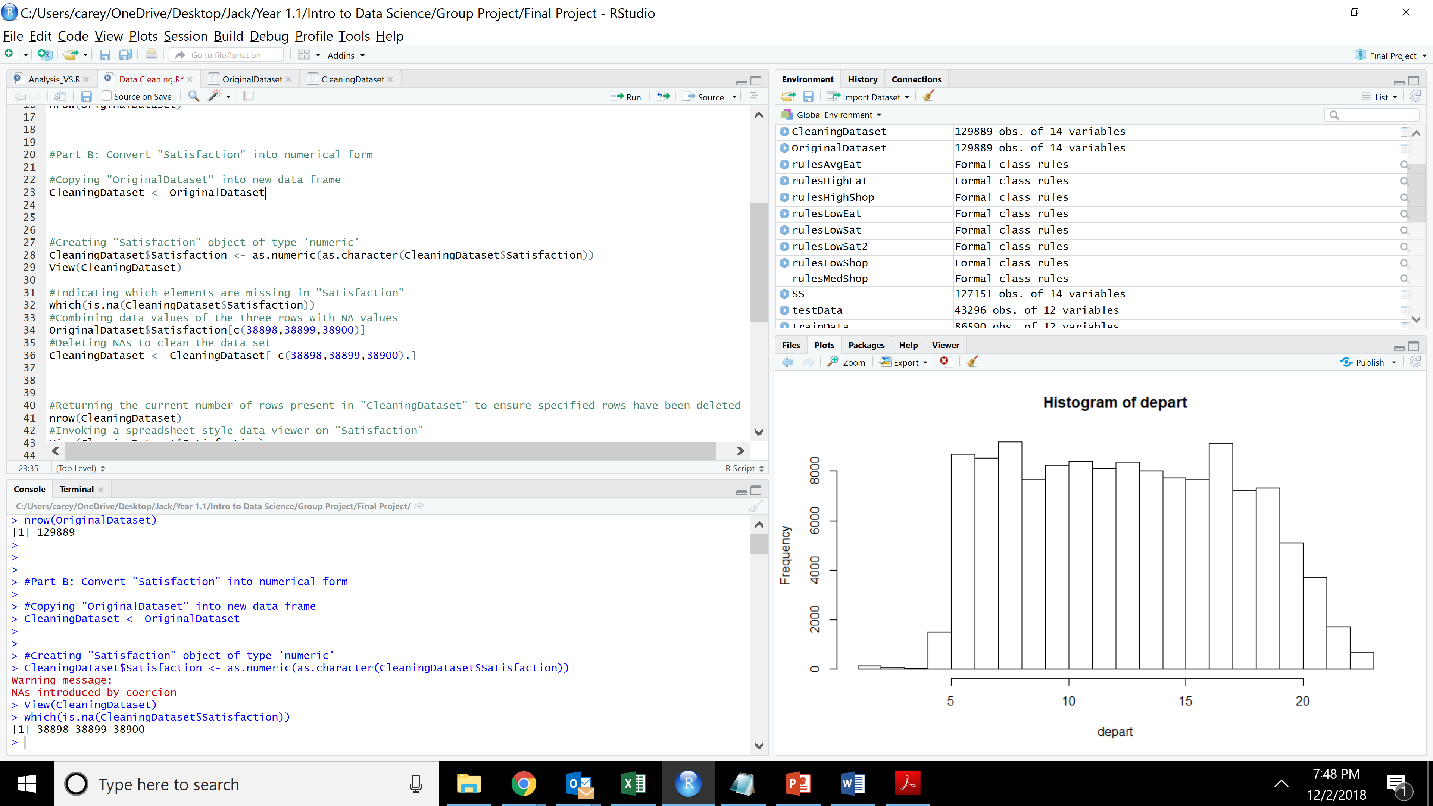

We then also decided to combine customer satisfaction values of 2.5 to 2, 3.5 to 3 and 4.5 to 5.

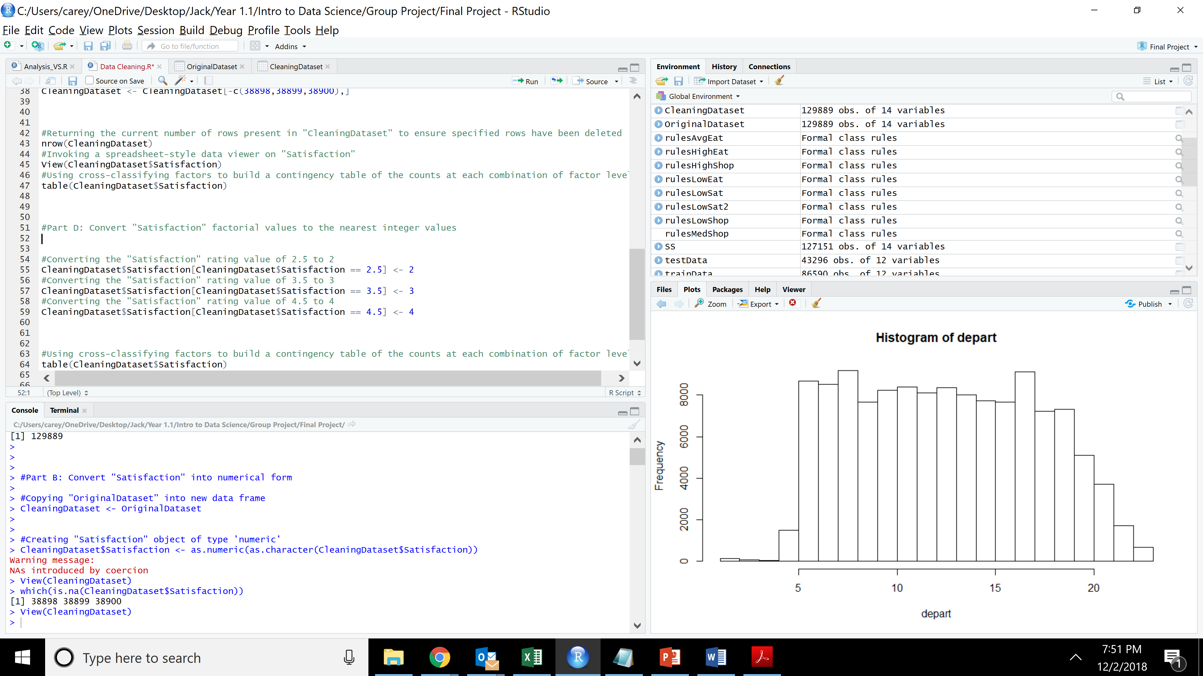

See *Data Cleaning* for full code.

## 2.3 CONVERTING DATA INTO BINS

We decided that for many of our models, we would want all of our data to be in categories. So, we split up the data as follows -

Any of the variables that were normal numeric values (Age, Shopping.Amount.at.Airport, and Eating.and.Drinking.at.Airport) we split them into bins as low, average and high based on the 40th and 60th quartile using the function below -­­­­

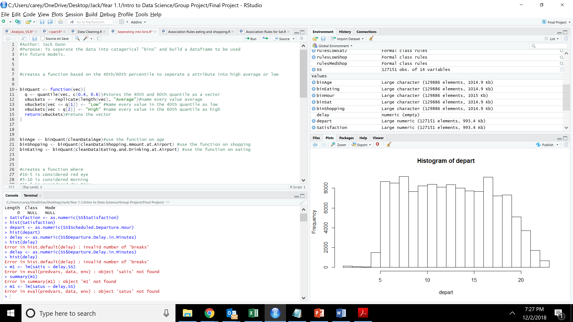

We used the rules and function below to separate the flight time into categories -

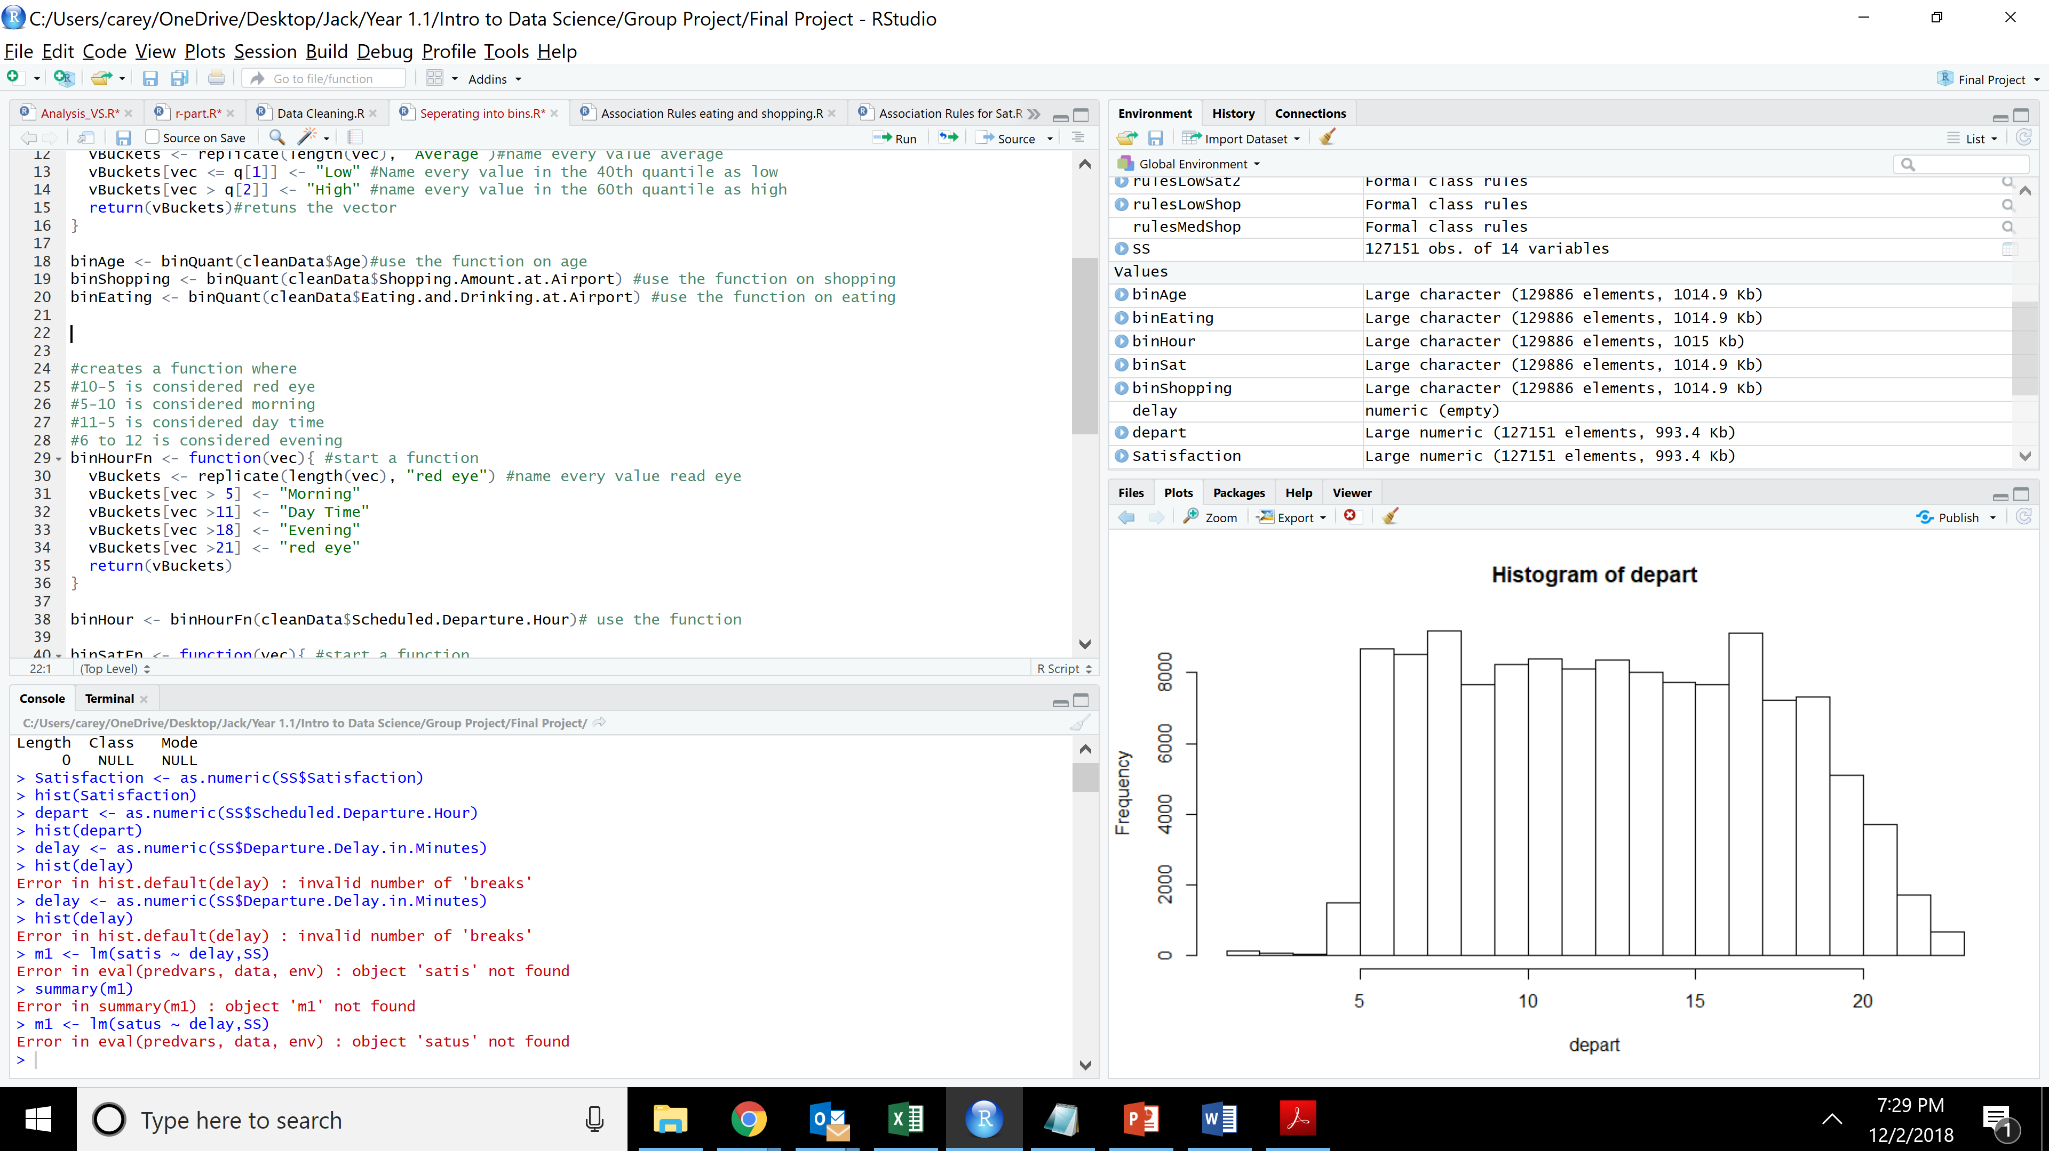

We decided that a customer satisfaction of 1 or 2 would be considered as low, a satisfaction of 3 or 4 would be average and 5 would be high. We used the code below -

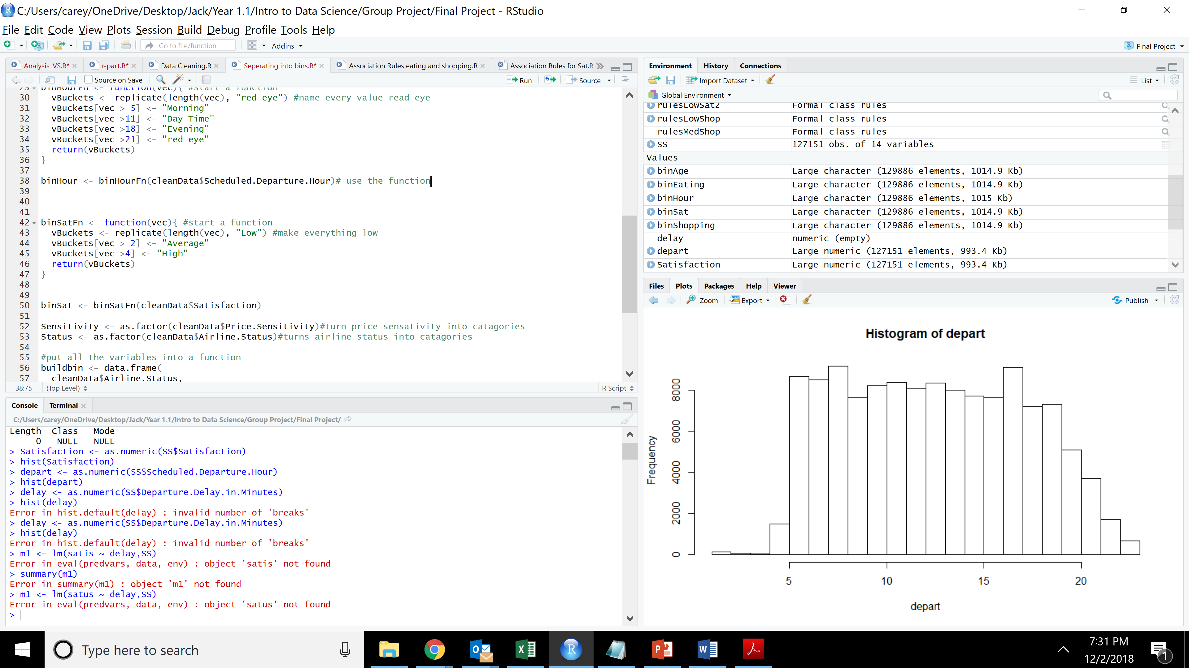

See *Separating into bins* for full code.

## 2.4 CREATING THE TEST AND TRAIN DATA SETS

We decided that for some of our models, we would want to test the validity of our model using a test data set. So we used this process to separate the data into a testing and training data set.

We started by creating a vector of one through the length of the data in random order -

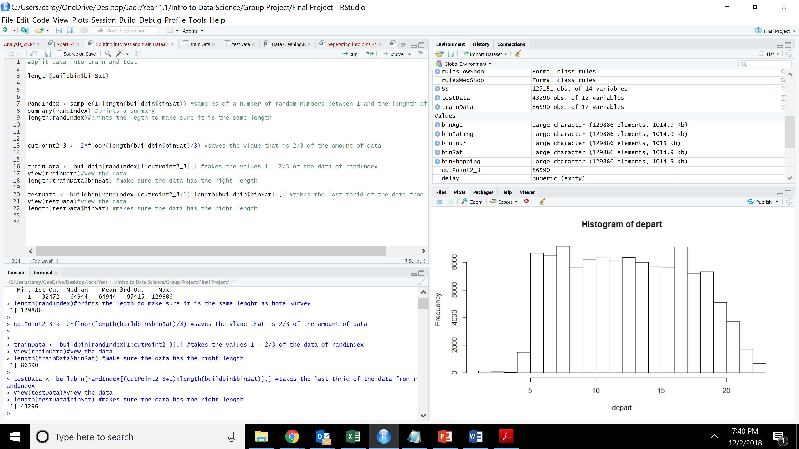

We then took two-thirds of the data at the index indicated by randIndex for our training dataset and the other third for our testing dataset -



See *Spliting into test and train Data* for full code.

## EXPLORATION OF VARIABLES

In this section, we explored each variable individually to see if we could gain any insights into the specific attributes. It also allowed us to become familiar with the data set as a whole.

## 3.1 SCHEDULED DEPARTURE HOUR AND DEPARTURE DELAY

The following observations were made by analyzing the two attributes:

* + - * There were 2345 NA's in the Departure delay in minutes column. Omitted the NA values from the data set in order to analyze it.
      * Highest no. of customers rated 6 out of 10 in Customer Satisfaction.
      * Maximum no of customers schedule their departure between 5 am and 8 pm.
      * Maximum flights don't delay for more than 100 minutes.

See *Analysis of scheduled departure hour and departure delay* for full code.

## 3.2 TYPE OF CLASS AND DELAY

We can see that the majority of customers were business travels and lowest were mileage travelers -

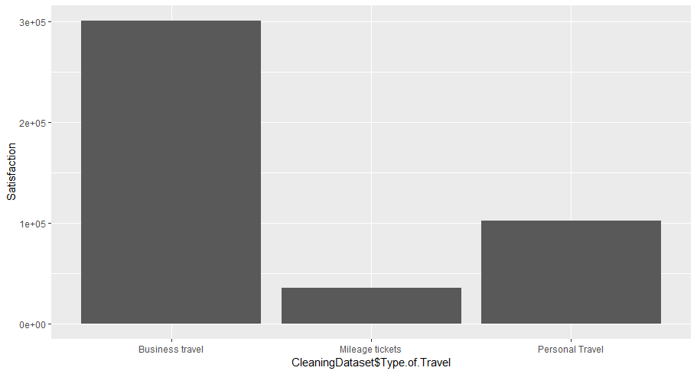

See *Analysis of Type of Travel and Class* for full code.

## 3.3 FLIGHTs CANCELLED AND ARRIVAL DELAY IN MINUTES

We tried visualizing arrival delay through graph -

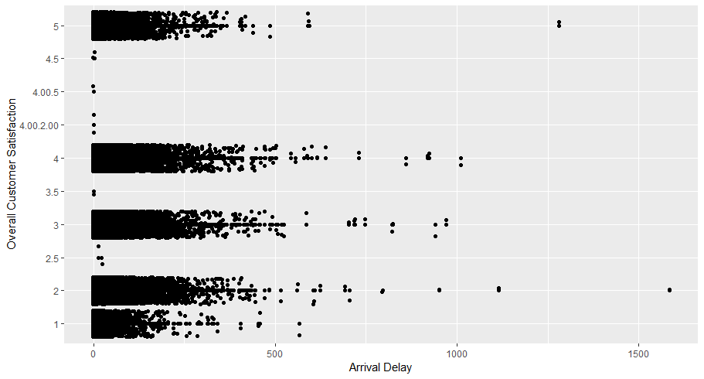

It does not show us a whole lot which leads us to think it does not require further investigation.

We then graphed whether the flight was cancelled or not -

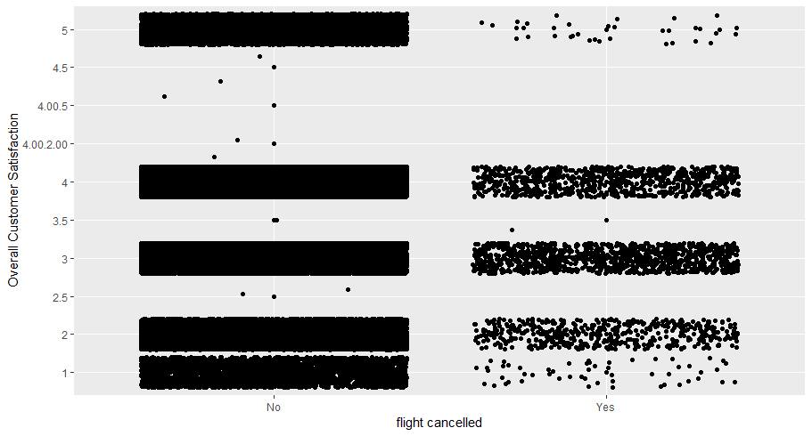

From this we can see that while most of the flights which were cancelled caused a lower satisfaction, there were still some people who gave a ranking of 5 even though their flight was canceled which was surprising to us.

See *Analysis of Arival Delay and Flight Cancelled* for full code.

## 3.4 GENDER AND PRICE SENSTIVITY

We found that there were disproportionate number of females to males -

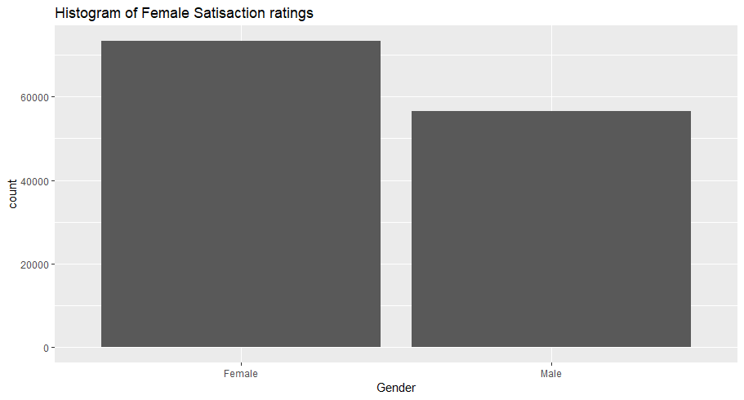

We also found that the satisfaction was fairly normal when graphed against gender, so we decided to pursue other categories.

We then printed a histogram of price sensitivity we found most have a price sensitivity of 2 -

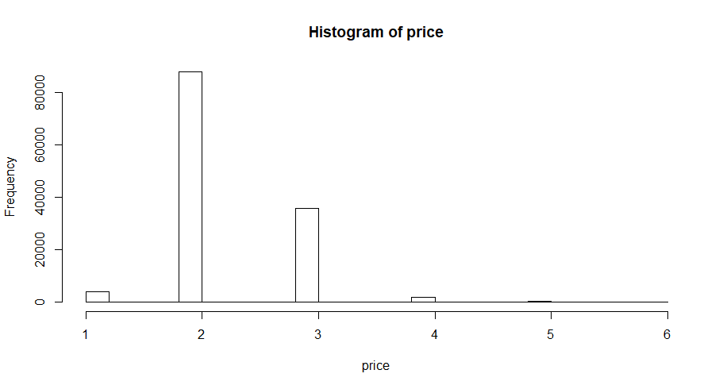

This was kept in mind in future models.

See *Analysis of Flight Cancelled and Arrival Delay* for full code.

## 3.5 EATING AND SHOPPING AT AIRPORT

EATING AND DRINKING AT AIRPORT

The amount of food spent on food by itself is not a good predictor. However, the maximum amount of spending on food is an okay predictor of satisfaction. However, it is not very good. I would recommend combining it with other variables like departure hour to see if certain types of people are more or less likely to spend more on food and if this effects their satisfaction.

SHOPPING AT AIRPORT

The amount of shopping is by itself not a good predictor. However if we take the max or even the mean of the amount spent, we get a fairly good mode l(note the model I built removed the satisfactions with low data points). Therefore, the more a customer spends on average, the more likely they are to give a higher rating. However, do note this is not the same thing as if a customer spends only a little, they will be dissatisfied.

See *Analysis of shopping and eating at the airport* for full code

## MODELS

In this section, we tried four different models to try and predict customers with low satisfaction. The four models are linear models, association rules, decision tree and support vector machine.

## 4.1 LINEAR REGRESSION MODEL

We used the Linear Regression Model to see how the independent variables affect the dependent variable in the data set, which is Satisfaction in this case.

We got some very interesting insights while pitting attributes like Type of Travel, Airline Status, Gender, Class, Price Sensitivity, Flight cancelled, and Delay in Arrival greater than 5 minutes against Satisfaction.

Here’s a list of a combination of the above-mentioned attributes and their Multiple R-squared value that determines how likely is a set of independent variables to affect the dependent variable.

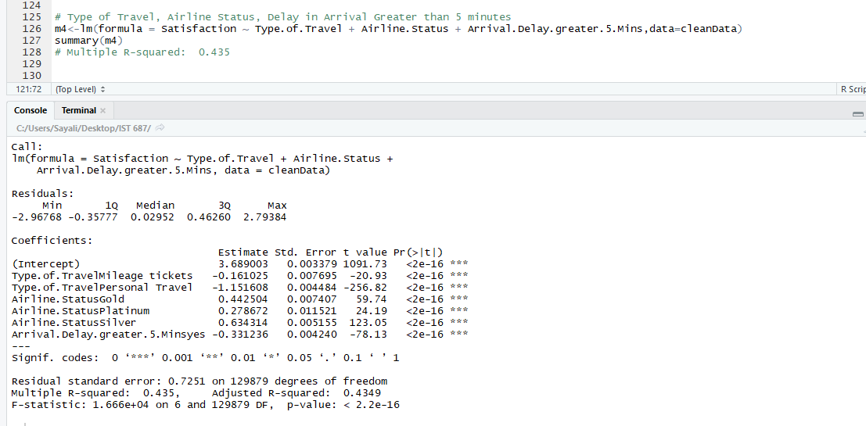

1. Type of Travel, Airline Status, Delay in Arrival Greater than 5 minutes

**Multiple R-squared: 0.435**

1. Type of travel, Class, Airline Status, Flight Cancelled

**Multiple R-squared: 0.4089**

1. Airline Status and Type of Travel

**Multiple R-squared: 0.4084**

1. Type of travel and Gender

**Multiple R-squared: 0.3385**

1. Type of Travel and Class

**Multiple R-squared: 0.3358**

1. Type of Travel

**Multiple R-squared: 0.335**

1. Airline Status and Gender

Multiple R-squared: **0.1344**

1. Airline Status and Class

Multiple R-squared: **0.1202**

1. Airline Status

Multiple R-squared: **0.1185**

1. Gender

Multiple R-squared: **0.01761**

1. Price Sensitivity

Multiple R-squared**: 0.007651**

1. Class

Multiple R-squared: **0.00254**

1. Shopping

Multiple R-squared: **0.0003079**

As depicted by the R-squared values above, as we moved to attributes like Shopping at the Airport, Class, Price sensitivity and others, the value of R-squared were insignificant to be considered relevant to the analysis. And thus, we would conclude that the above bold values of attributes best affect the Satisfaction of the airline customers.

See *Linear Models* for full code

## 4.2 ASSOCIATION RULES

We deiced to find association rules to predict low customer satisfaction. To do this, we used an apori algorithm to find rules with low customer satisfaction on the right hand side.

We started with a minimum confidence and support of 0.15 -

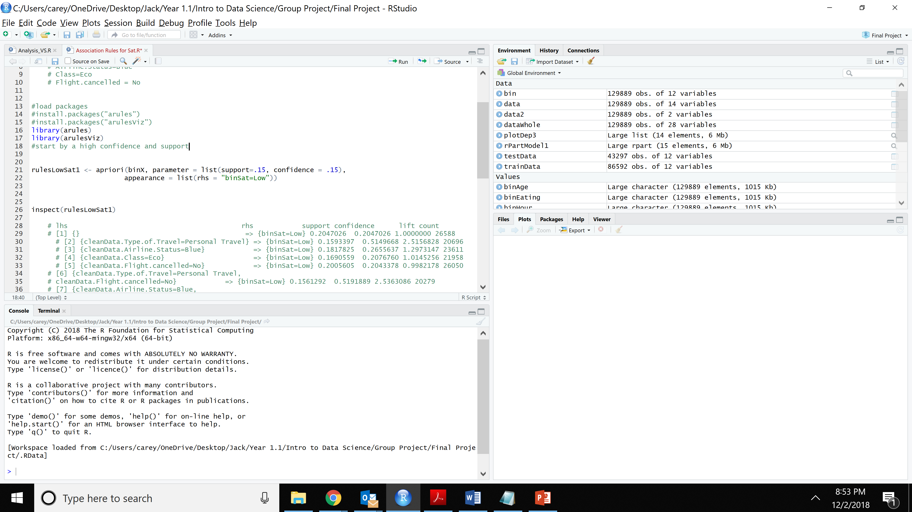

We got the rules -

|  |  |  |  |  |
| --- | --- | --- | --- | --- |
| Rule | support | confidence | lift | count |
| Type.of.Travel=Personal Travel | 0.1593397 | 0.5149668 | 2.5156828 | 20696 |
| Airline.Status=Blue | 0.1817825 | 0.2655637 | 1.2973147 | 23611 |
| Class=Eco | 0.1690559 | 0.2076760 | 1.0145256 | 21958 |
| Flight.cancelled=No | 0.2005605 | 0.2043378 | 0.9982178 | 26050 |
| Type.of.Travel=Personal Travel,  cleanData.Flight.cancelled=No | 0.5191889 | 2.5363086 | 2.5363086 | 20279 |
| Airline.Status=Blue,  flight.cancelled=No | 0.2657863 | 1.2984023 | 1.2984023 | 23146 |
| Class=Eco,  Flight.cancelled=No | 0.2072841 | 1.0126112 | 1.0126112 | 21485 |

This led us to a list of customers who tend to be dissatisfied.

* + - * Type of Travel is personal
      * Airline Status is blue
      * Class is economy
      * Flight cancelled is not cancelled

When running models with several different values of minimum support and confidence, we found that there were many variables with really high confidence but low support. This led us to try running the model again with a minimum support of 0.10 and a minimum confidence of 0.60.

This led us to the rules below -

|  |  |  |  |  |
| --- | --- | --- | --- | --- |
| Rule | support | confidence | lift | count |
| Airline.Status=Blue,  Type.of.Travel=Personal Travel | 0.1448501 | 0.6043105 | 2.952139 | 18814 |
| Airline.Status=Blue,  Type.of.Travel=Personal Travel, Class=Eco | 0.1185116 | 0.6036234 | 2.948782 | 15393 |
| Airline.Status=Blue,  Type.of.Travel=Personal Travel,  Flight.cancelled=No | 0.1419399 | 0.6096359 | 2.978154 | 18436 |
| Airline.Status=Blue,  Type.of.Travel=Personal Travel, Class=Eco, Flight.cancelled=No | 0.1159940 | 0.6090718 | 2.975399 | 15066 |

This just validates our findings above since it shows that the customers who are least happy are the ones that have a combination of the traits listed above.

See *Association Rules for Sat* for full code.

## 4.3 DECISION TREE

We decided to create a decision tree to see if we could again predict the customers with low satisfaction (1-2). We used the packages rpart and rpart.plot for this model.

We started by using three levels.

The code we used was -

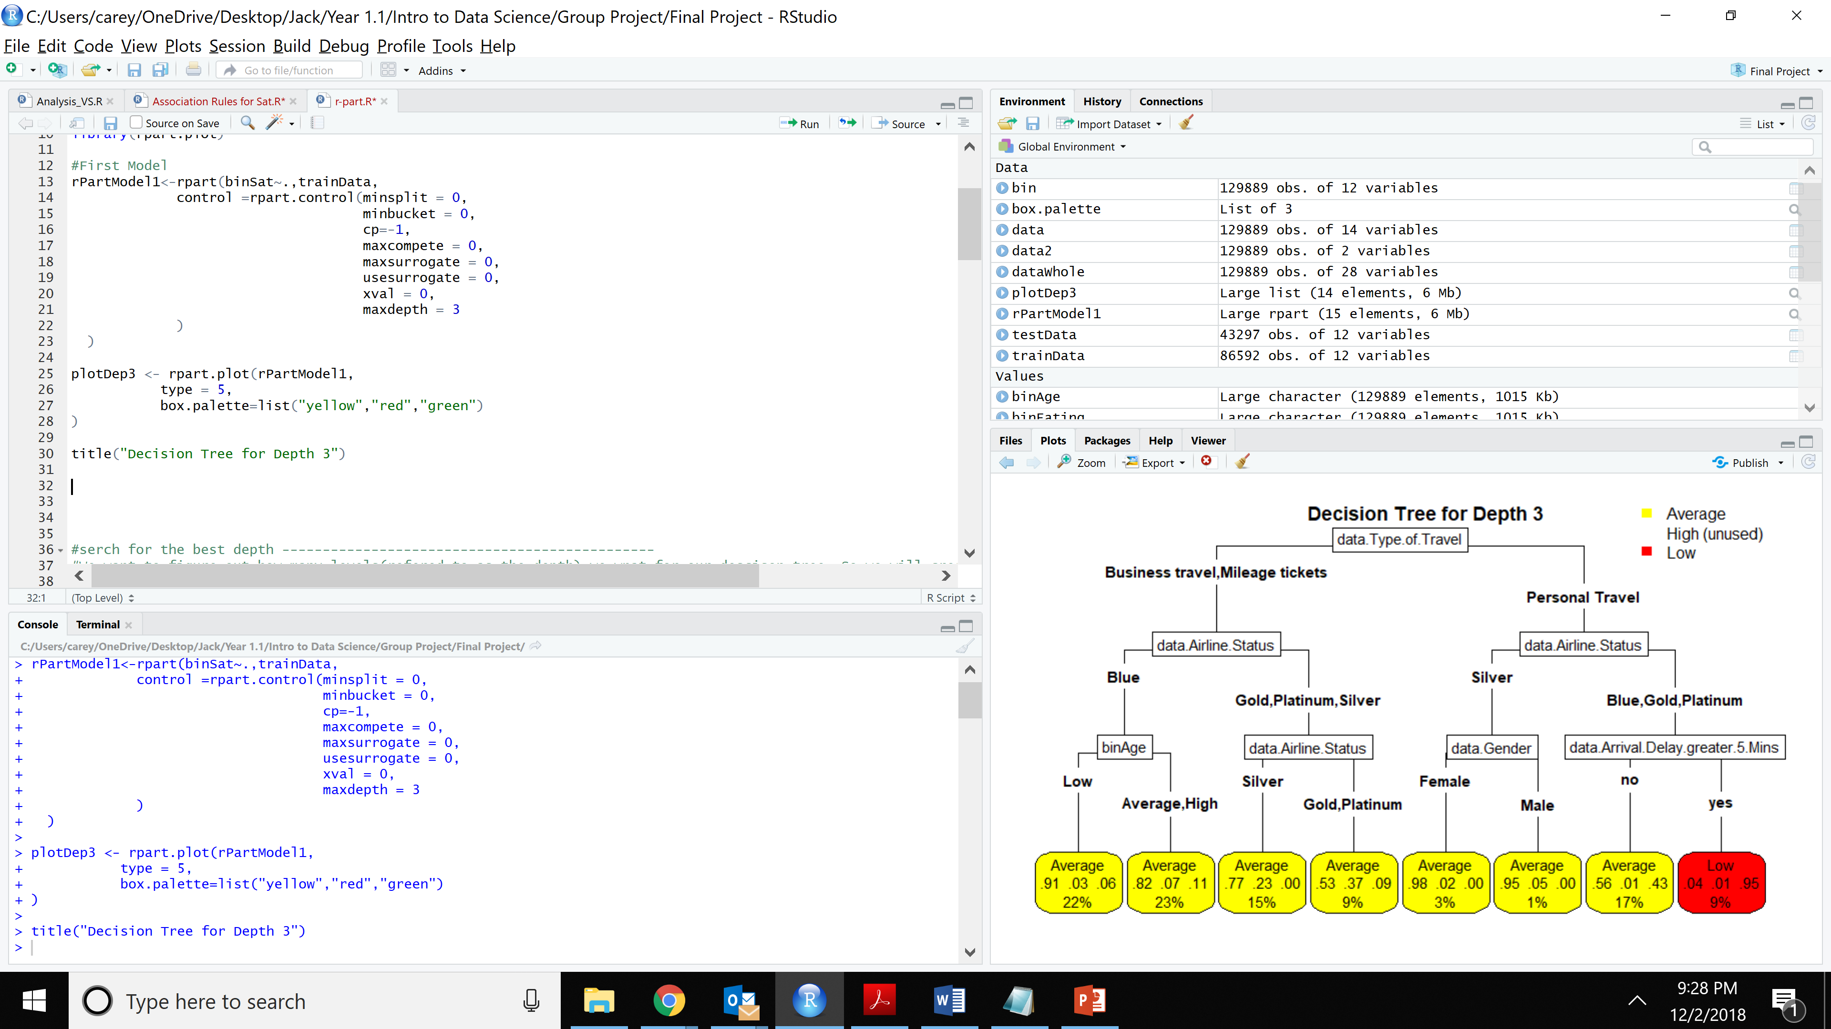

This is the plot we got -

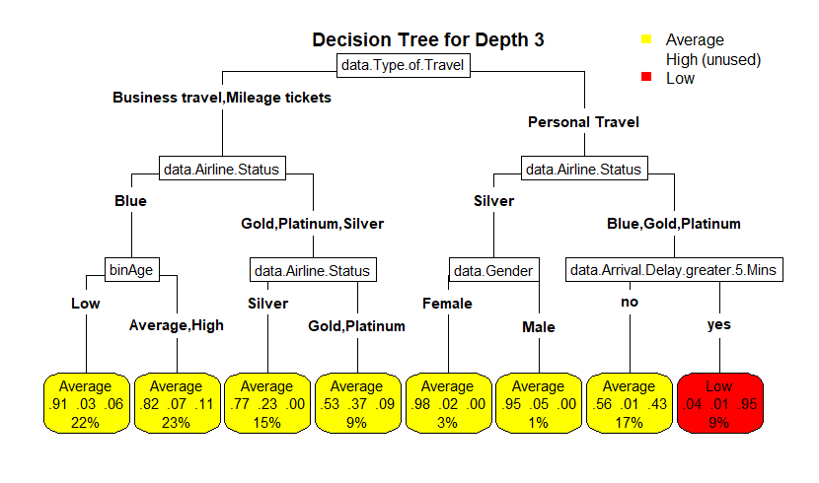

This is very similar to our finding from the association rules. We find that the least happy customers are those that personal travels. One interesting thing we found was that personal travel customers who had an airline status of silver were happiest. This is something to look into more.

We then decided to try to find what the best depth would be. We used a for loop to calculate the error rates and store them in a vector -

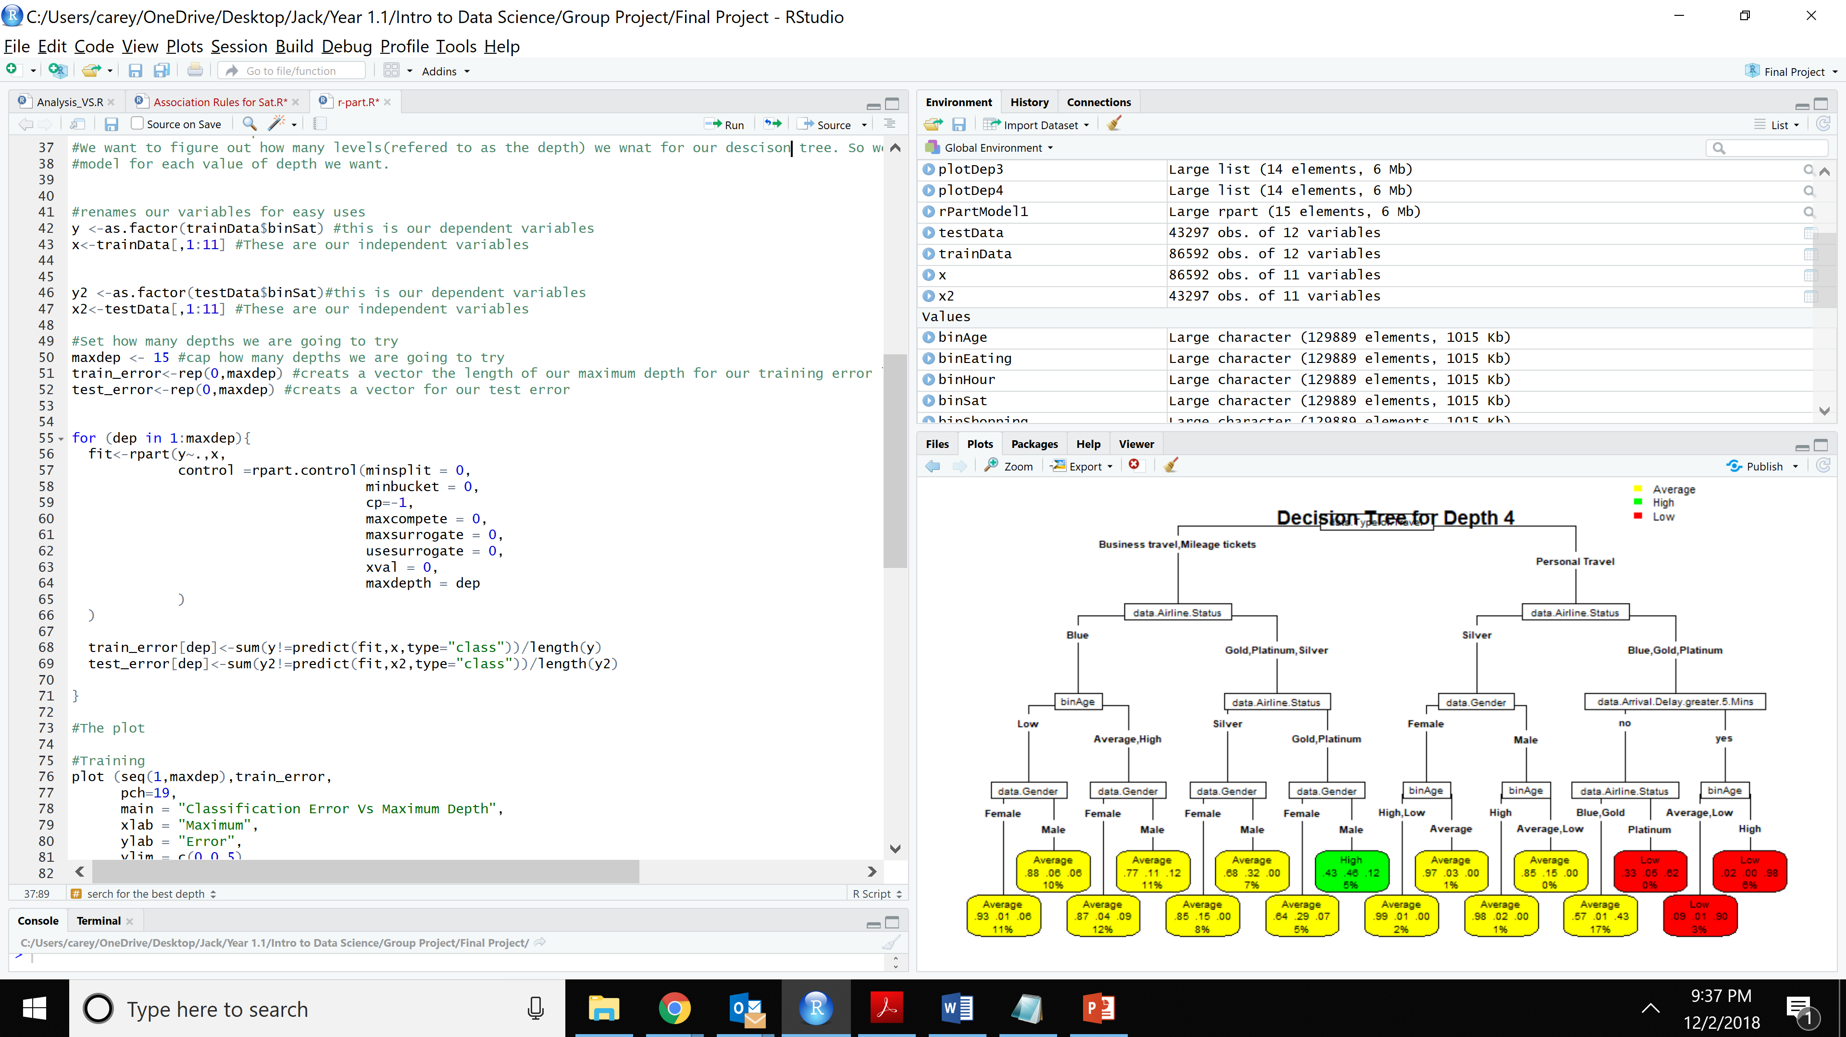

We then plotted this vector to see what the error rate looks like -

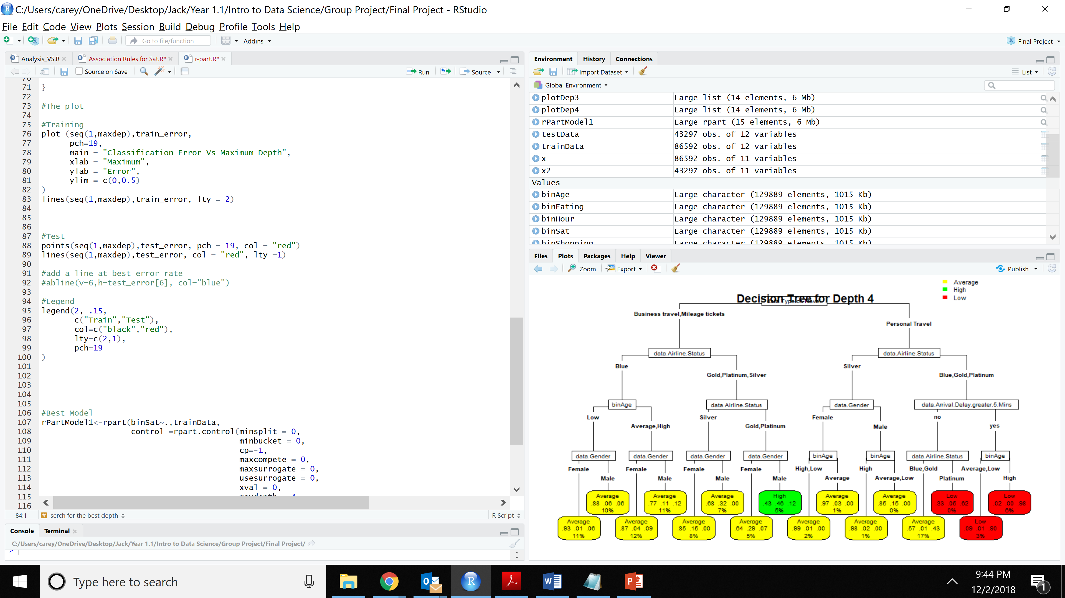

We get the plot -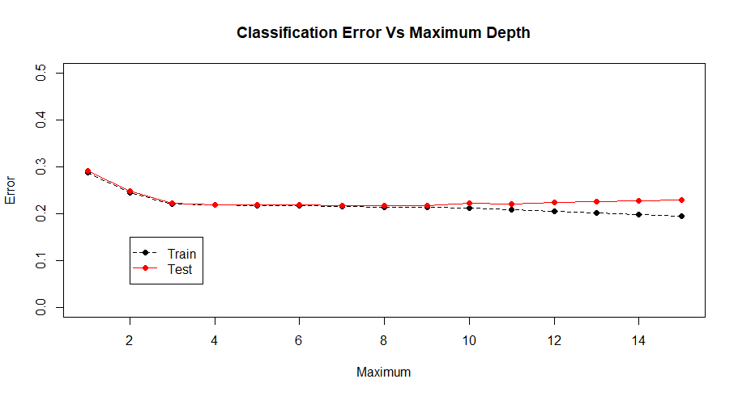

We can see here that the depth does not have a huge effect of the error rate so we will not be worried with it.

After running a few more models with different depths, we decided that a depth of 3 and a depth of 4 were the most useful models.

With a depth of 4, we get the plot below -

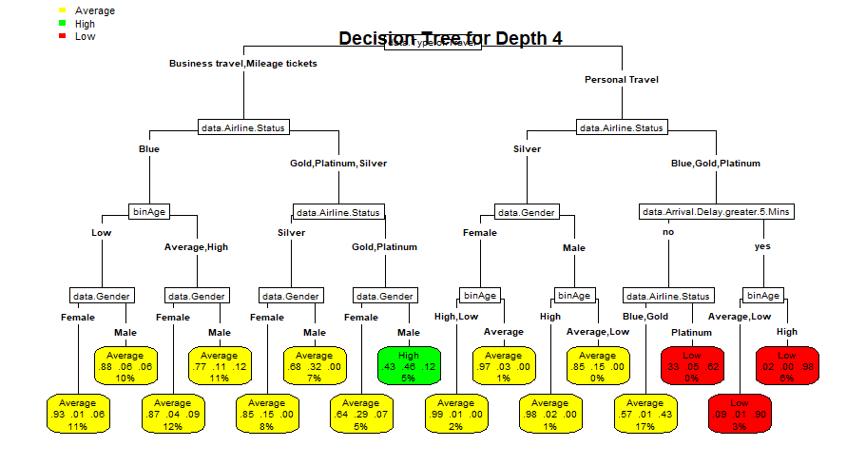

The only reason we found this interesting is that we found the customers with the highest satisfaction which was males who were gold or platinum members who were business or mileage travelers.

See *r-part* for the full code.

## 4.4 SUPPORT VECTOR MACHINE

We tried to see if a support vector machine would be able to validate our findings in the previous models. However, when we tried several different things, our computers were not able to process the information. The things we tried were:

* + - * Making a model to predict a customer satisfaction of low, average or high using all of our variables.

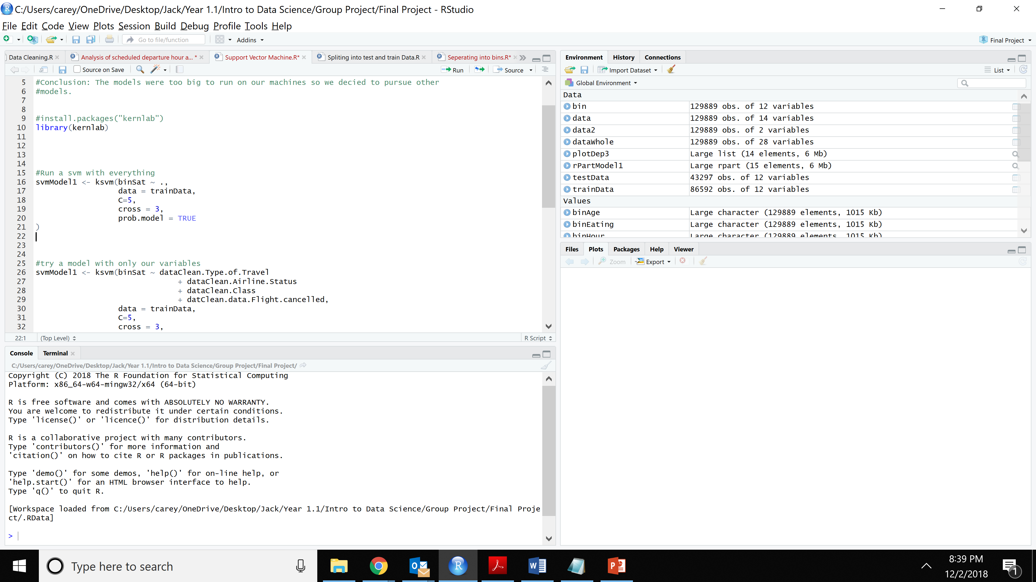

* + - * Making a model to predict a customer satisfaction of low, average or high using just the variables
        + Type of Travel
        + Airline Status
        + Class
        + Flight. Cancelled

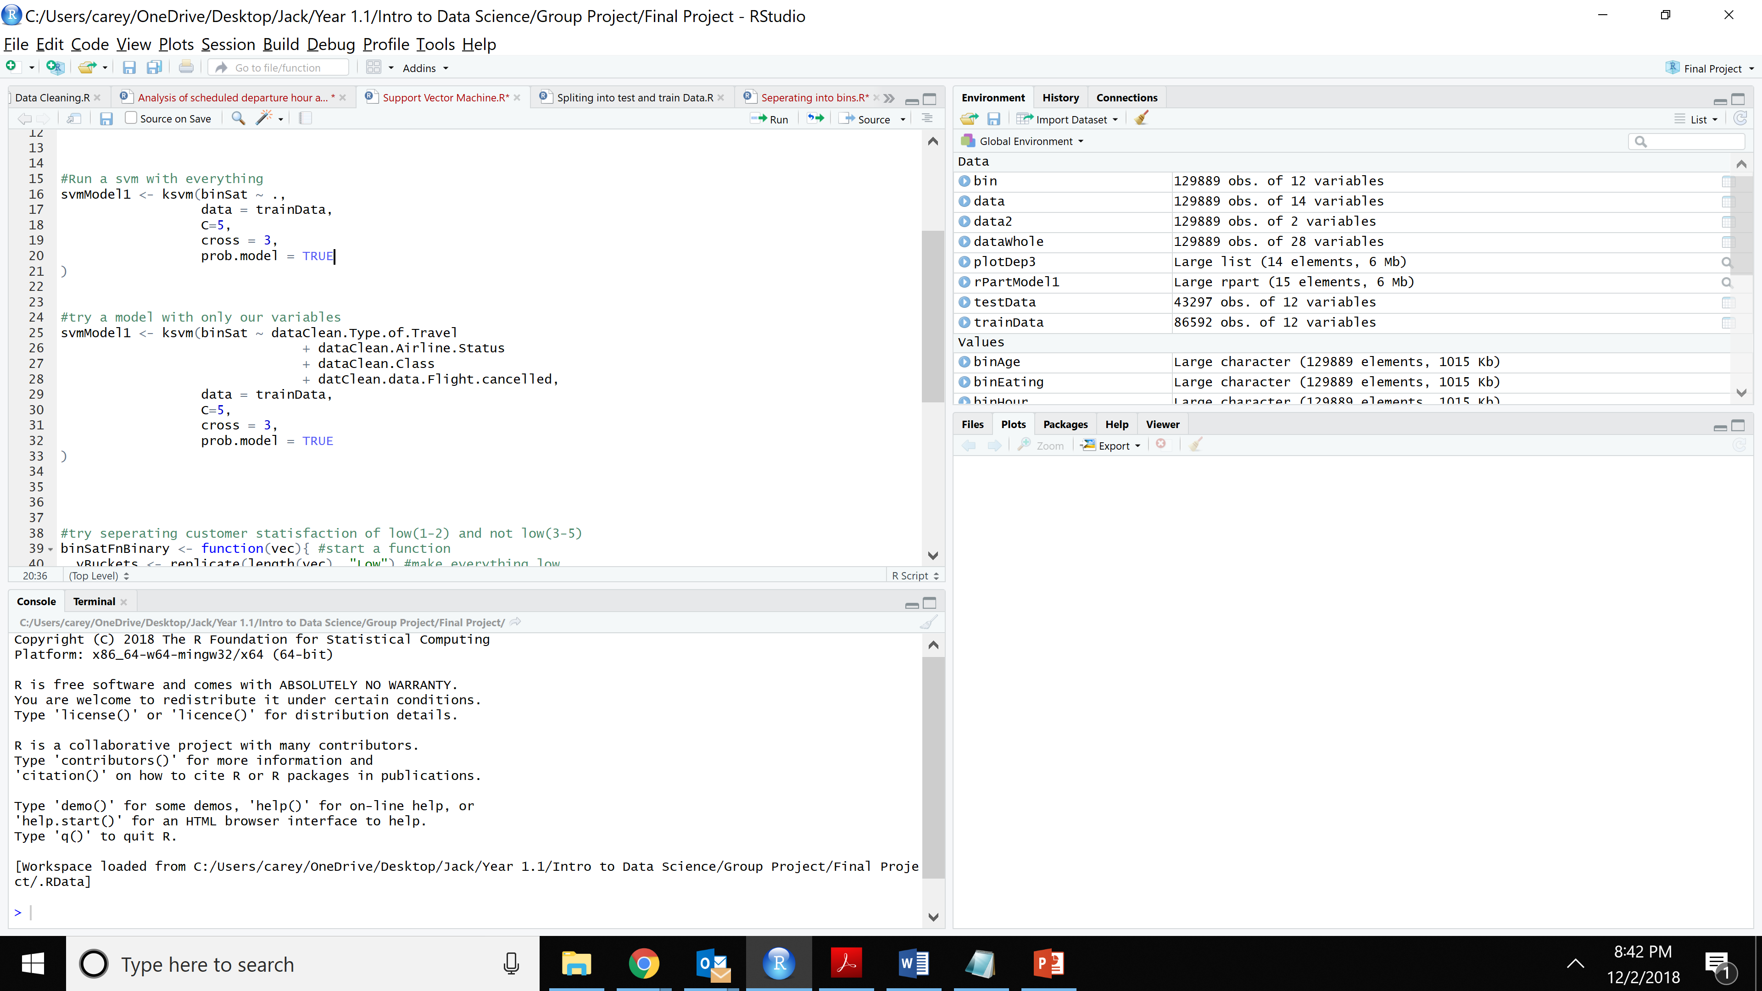

* + - * Making a model to predict a customer satisfaction of low(1 or 2) or not low (3-5) using just the variables. We used the code below to make satisfaction binary

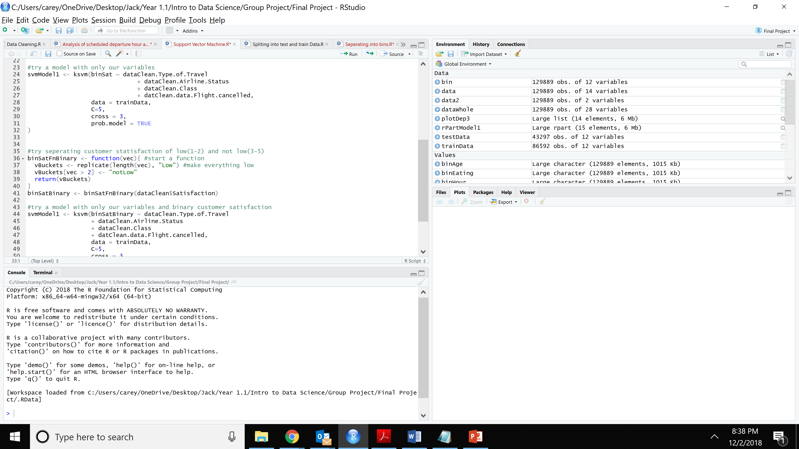

The model finally used was

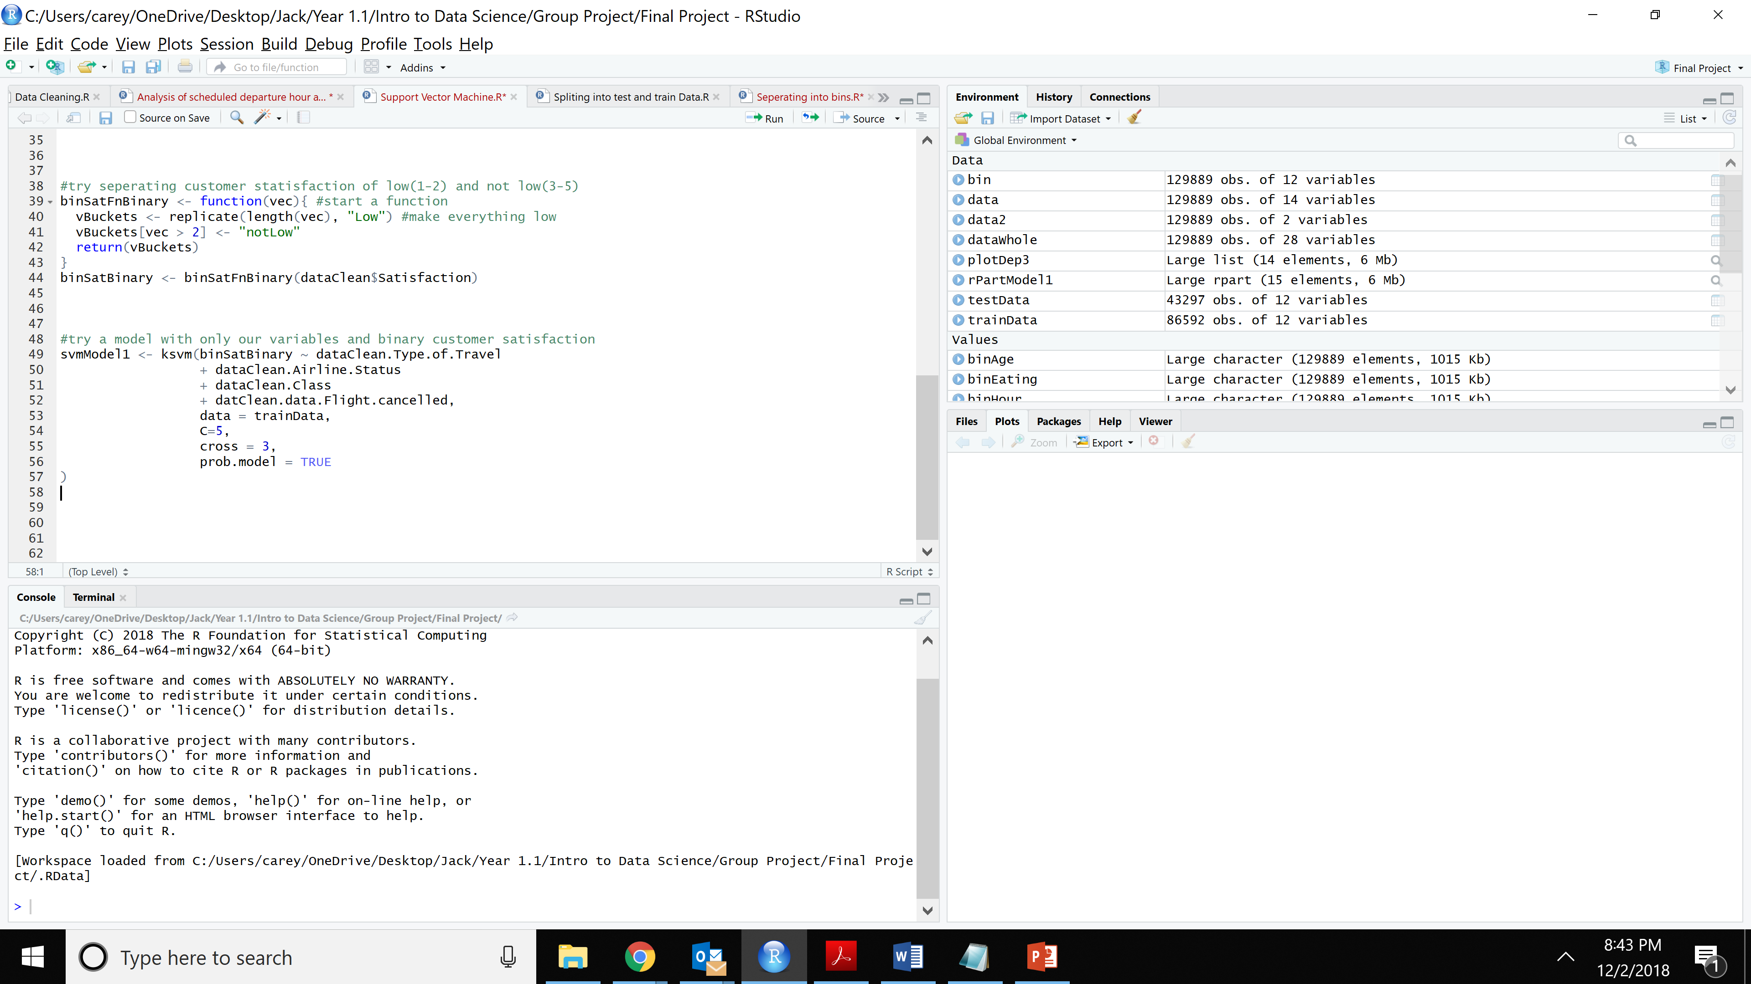

Since our computers were having trouble running the models, we decided to abandon the model in favor of other techniques.

See *Support Vector Machine* for full code

## VALIDATION OF MODELS

We decided to try and validate our models my comparing the average customer satisfaction by the variables we found to be important.

|  |  |  |
| --- | --- | --- |
| Attribute | | Mean |
| Type Travel | Business | 3.77136 |
| Millage | 3.543098 |
| Personal | 2.5503 |
| Delay | > 5min | 3.49015 |
| < 5 min | 3.166884 |
| Gender | male | 3.52526 |
| female | 3.267033 |
| Status | silver | 3.942429 |
| gold | 3.743748 |
| platinum | 3.644056 |
| blue | 3.158105 |

As we can see, the average customer satisfactions are indeed lower for personal travelers, females, and blue status travelers. Also, the customer satisfaction is very high for silver travelers. This is all the same as our previous models. Unexpectantly, the average satisfaction is higher for people who had a delay of greater than five minutes. While this would be something for further analysis, one reason this might be that over twice as many people did not have delays then did have delays.

See *Validation of Model* for full code

## VISUALIZATION OF VARIABLES

We decided to take a closer look at the attributes that we found to be important from our models.

Attribute: Satisfaction

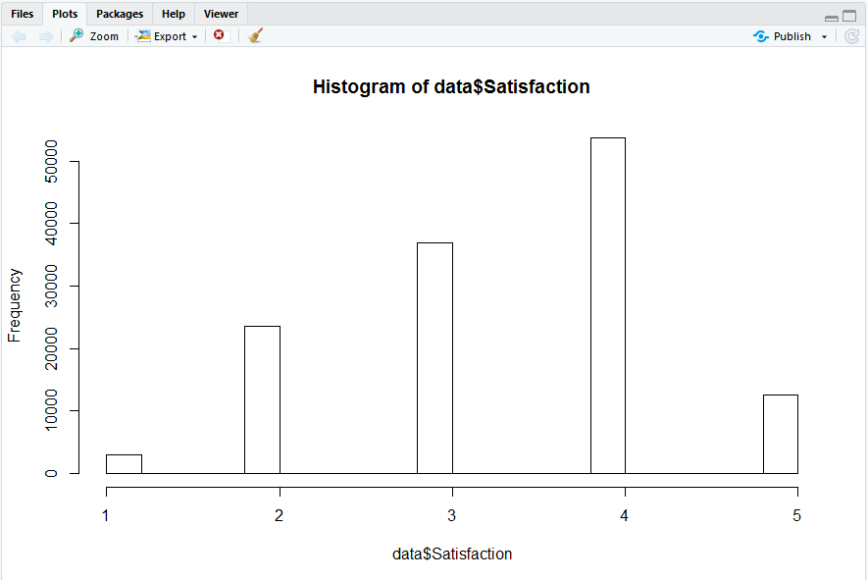

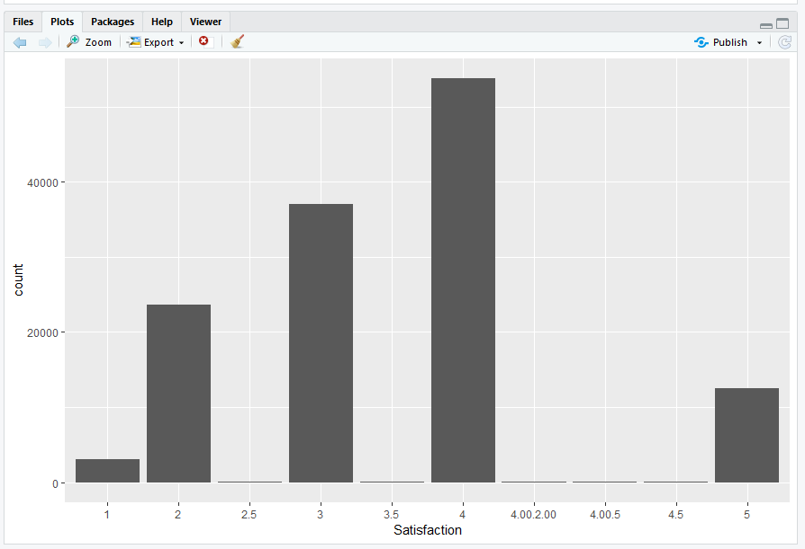

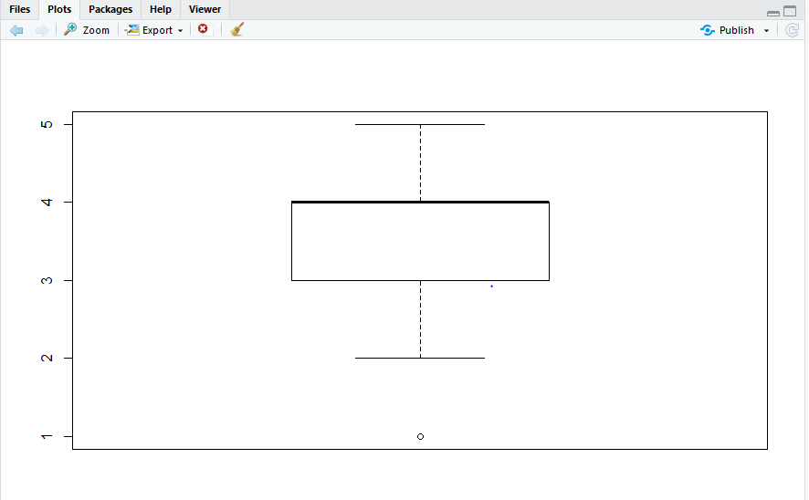

Attribute: Type of travel

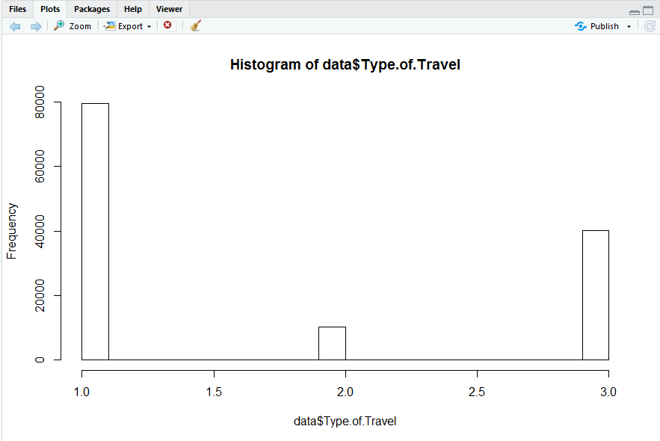

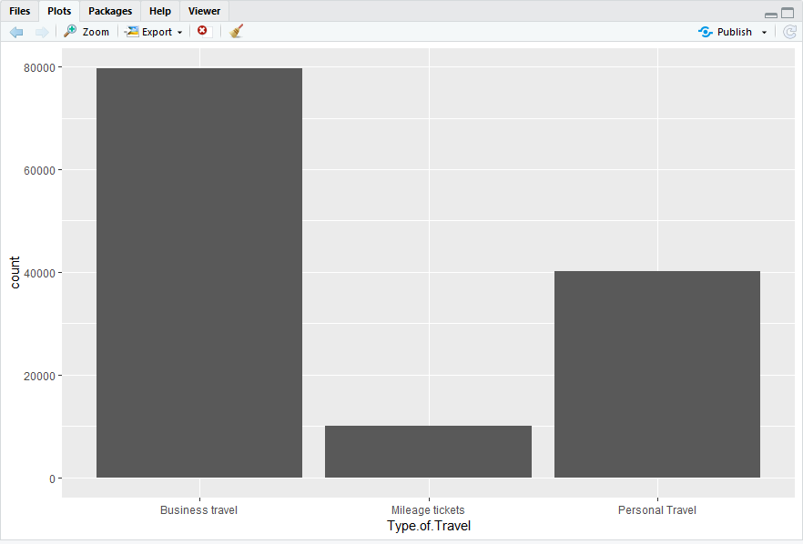

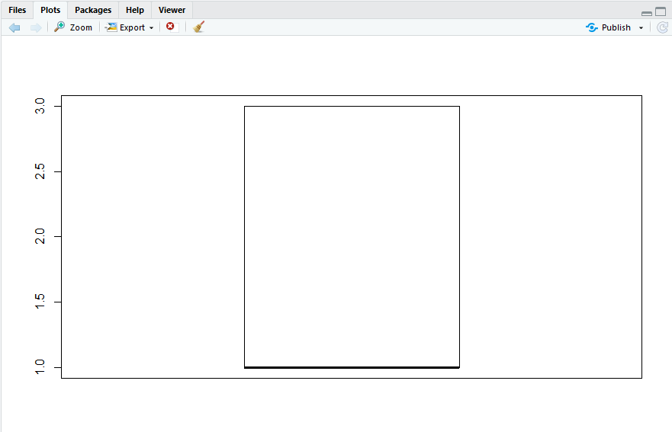

Attribute: Airline status

Barplot using ggplot -

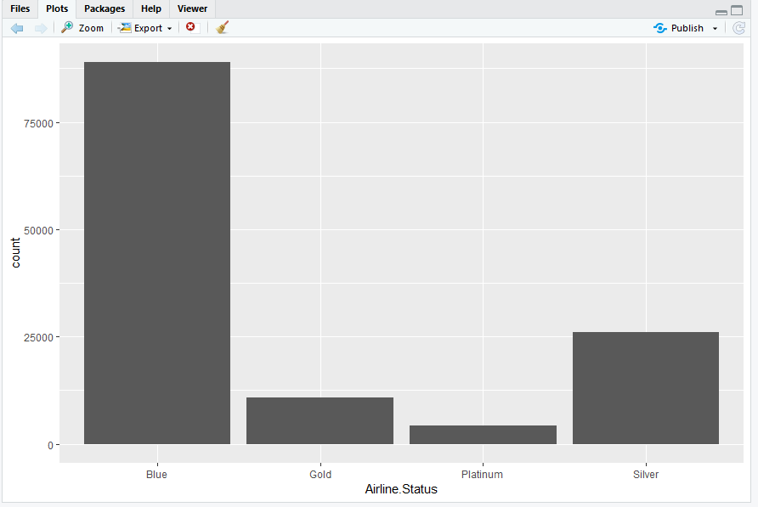

Jitter for airline status and satisfaction -

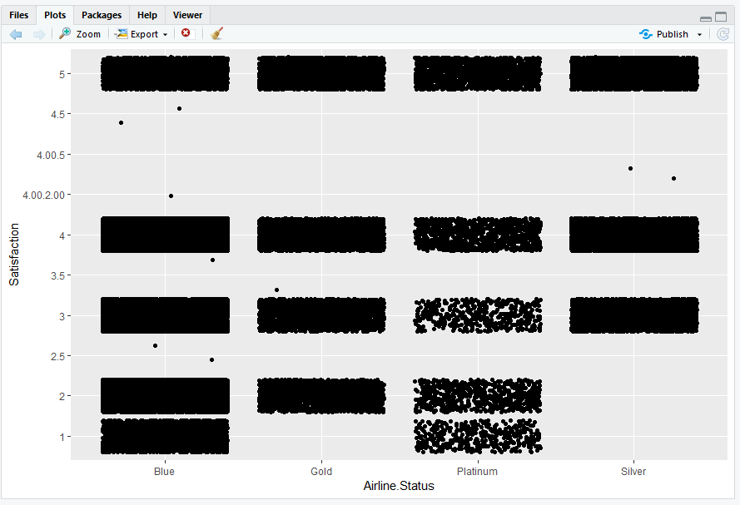

Attribute: Class

Barplot for class using ggplot -

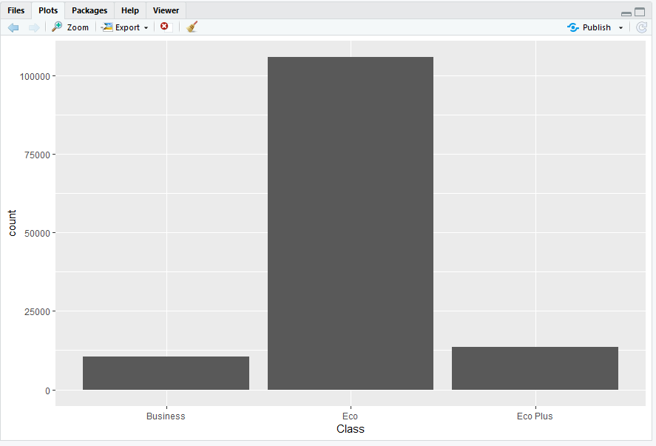

Jitter for class and satisfaction

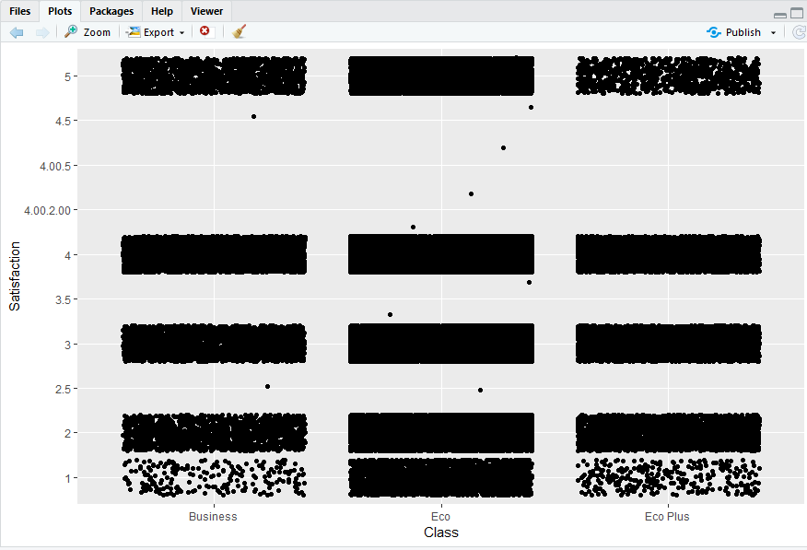

Attribute: Flight Cancelled

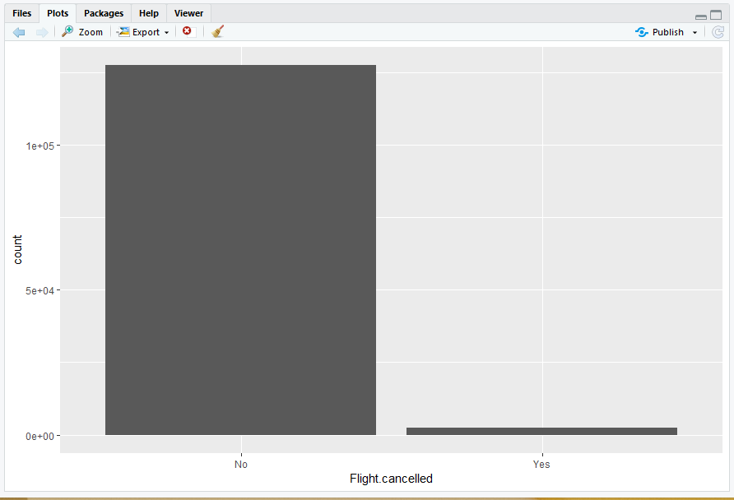

Flight cancelled and satisfaction

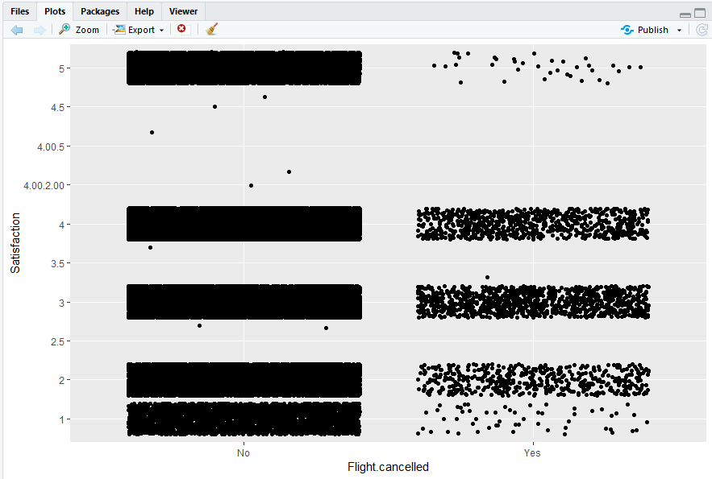

Attribute: Arrival.delay.greater.5.mins

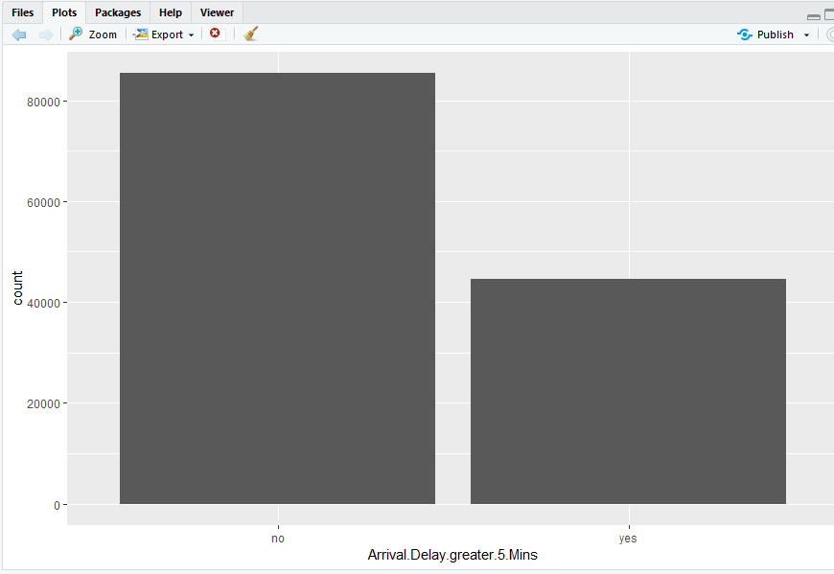

Jitter for arrival delay and satisfaction

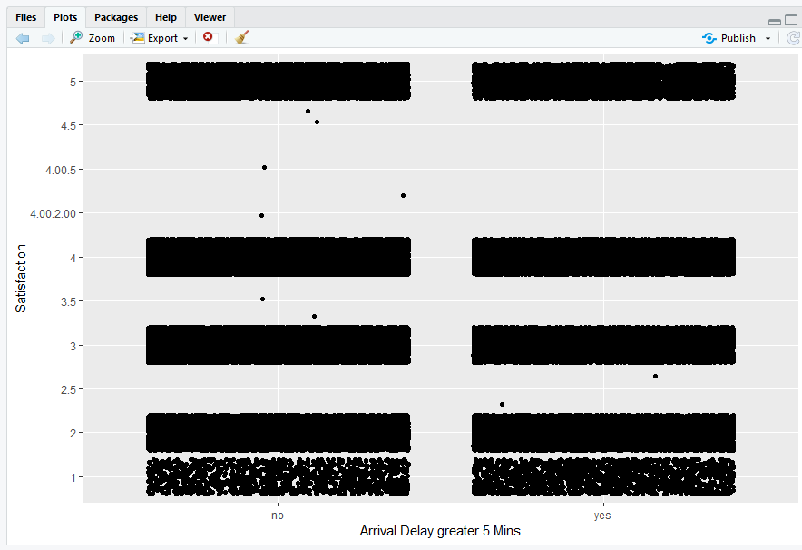

## CONCLUSION

To conclude let us look at the answers we found for our business questions –

1. Which of the factors surveyed are likely to affect the overall customer satisfaction?

We found out that there are four factors which are likely to affect the overall customer satisfaction. These are Type of Travel, Arrival Delay, Airline Status and Class.

1. Do obvious factors like the Airline ticket prices, flight arrival delay or cancellation really affect the overall customer satisfaction?

Through our analysis we came to a conclusion that Arrival Delay and Cancellation did indeed have an effect on the overall customer satisfaction rate. However, Ticket Price did not have much effect.

1. Are there any generalized trends across all the airlines?

Further into the analysis we found four generalized trends across all the airlines. These are Type of Travel, Arrival Delay, Airline Status and Class.

1. What type of travelers are most satisfied with the airlines?

Business Travelers are most satisfied with the airlines.

1. What type of travelers are least satisfied with the airlines?

Personal Travelers are actually the least satisfied airlines travelers.

1. What class of travelers are the least satisfied?

Economy class was found to be most dissatisfied with the airlines.

1. Between men and women, who is more satisfied with the airlines?

Males had a comparatively higher satisfaction rate than the females.

So our primary findings showed that Personal Travelers were the least satisfied. We also found that especially those who were in the Blue Airline Status and Economy Class were often dissatisfied. This led us to believe that Bargain Shoppers are the ones we should focus more on than the other customers. Maybe services like coupons and deals might boost their satisfaction rates.

Later on in our analysis we did find something interesting. The Silver Status had an unusually high average customer satisfaction. This means that the silver program is a functional program and should be looked on further to see why these customers are happy. May be perhaps in future we may implement some of the program’s perks provided by the Silver Status into the other aspects of the airline.

## REFERENCES

1. Intro to Data Science Text book
2. Person Anderson
3. Professor Lee

## APPENDIX

## 9.1 R CODE

Analysis of Arival Delay and Flight Cancelled.R

Analysis of Gender and Price Sensitivity.R

Analysis of scheduled departure hour and departure delay.R

Analysis of shopping and eating at the airport.R

Analysis of Type of Travel and Class.R

Association Rules for Sat.R

Data Cleaning.R

Linear Models.R

r-part.R

Seperating into bins.R

Spliting into test and train Data.R

Support Vector Machine.R

Visualizations of Variables.R

## 9.2 TRELLO BOARD

